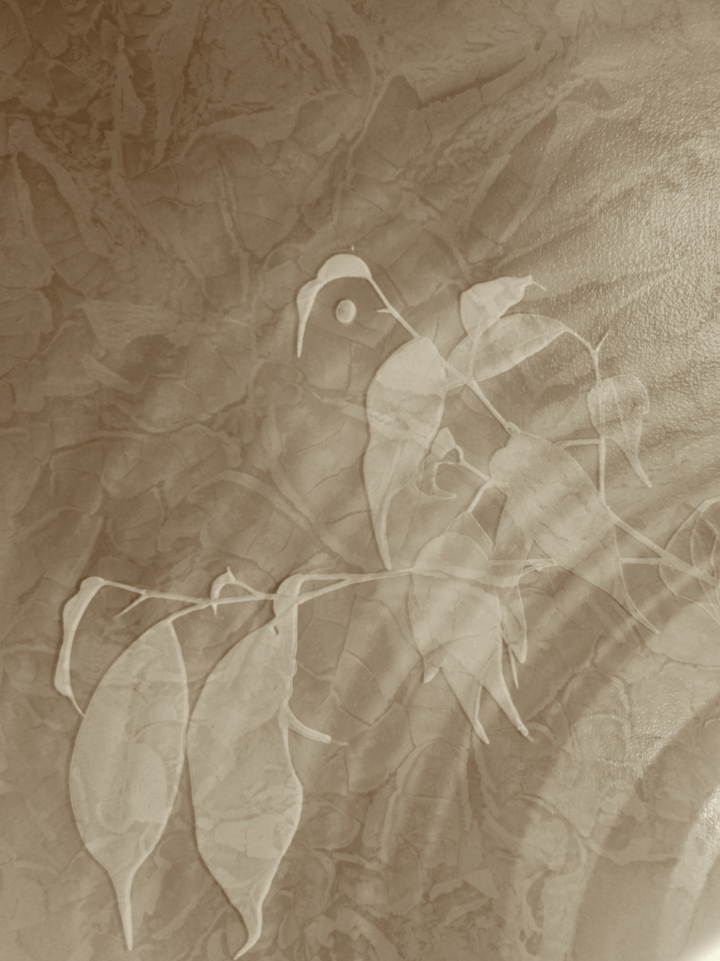

Keinjan Logo Competition 2023

Keinjan Elders Aboriginal Corporation

Expression of Interest
We are looking for Keinjan artists to enter the 2023 Log Competition.
Theme for Artwork
Keinjan artists are to design a logo that is a representation of the Keinjan Elders Aboriginal Corporation (KEAC) and Elders representing the rights and interests of the Keinjan Tribe.
Completion Dates
The competition opens 30th September 2023 and closes 30th November 2023. The winner will be announced the week commencing 12th December 2023.
KEAC is seeking artwork that will
- Be used for the corporation logo.
- Provide a design that will be used in all KEAC marketing materials.
- Be used on the KEAC website, social media sites, posters, printed materials, gifts, or anywhere else organizers choose.
Prize
$200 cash is on offer in the first ever Keinjan Elders Aboriginal Corporation NAIDOC art competition.
How to Enter
- Review the Terms and Conditions of the entry
- Complete the entry form
- Submit an entry in one of the following ways
Email – Send a completed and signed entry form and an image of the artwork to keinjanelders@gmail.com
Post - A completed and signed entry form and an image of the artwork to: KEAC Art Competition – 18 Ward Street Mareeba QLD 4880.
Drop off - A completed and signed entry form and an image of the artwork to: KEAC Art Competition – 18 Ward Street Mareeba QLD 4880
For inquires email: keinjanelders@gmail.com



